**Project-1**

**Deploying three-tier architecture in AWS using Terraform**

**Step-1**: create a provider file

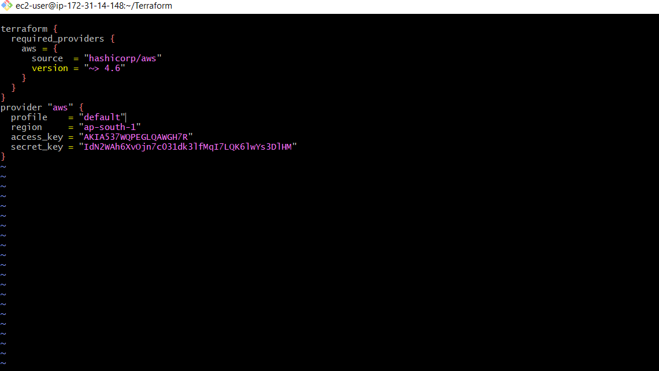



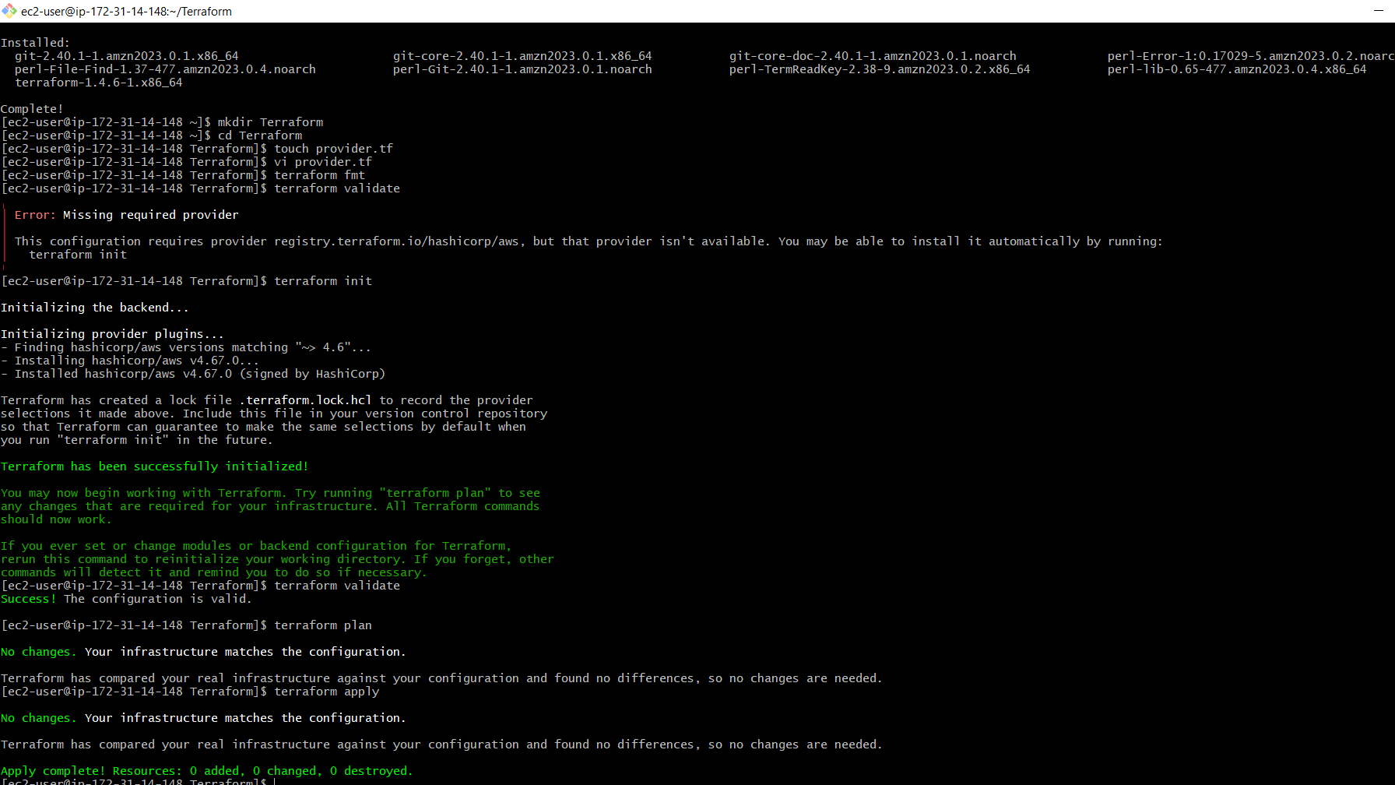

**Step-2**:create a file for vpc

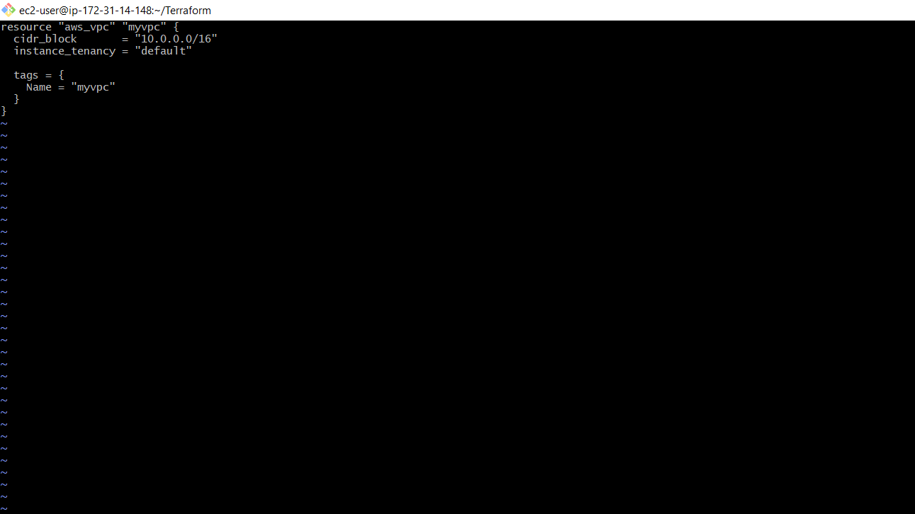

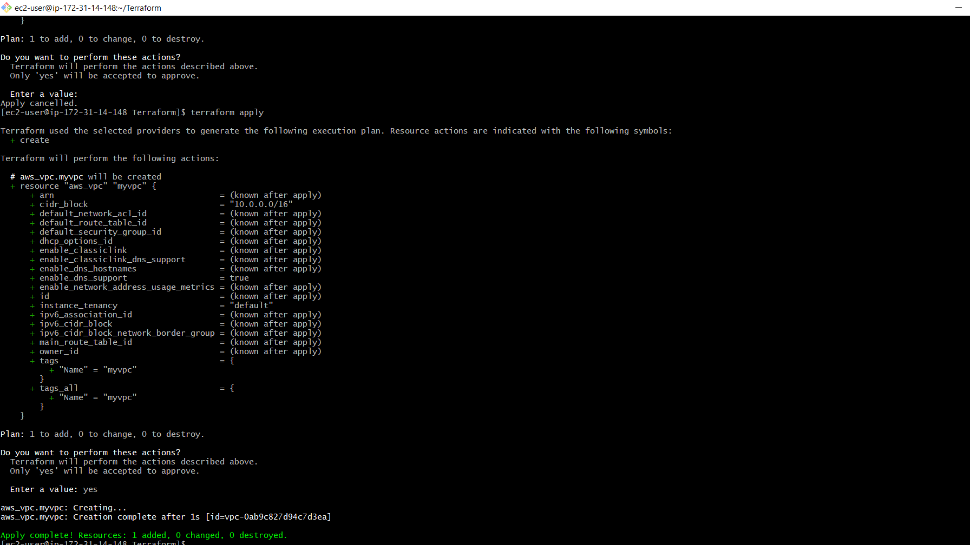

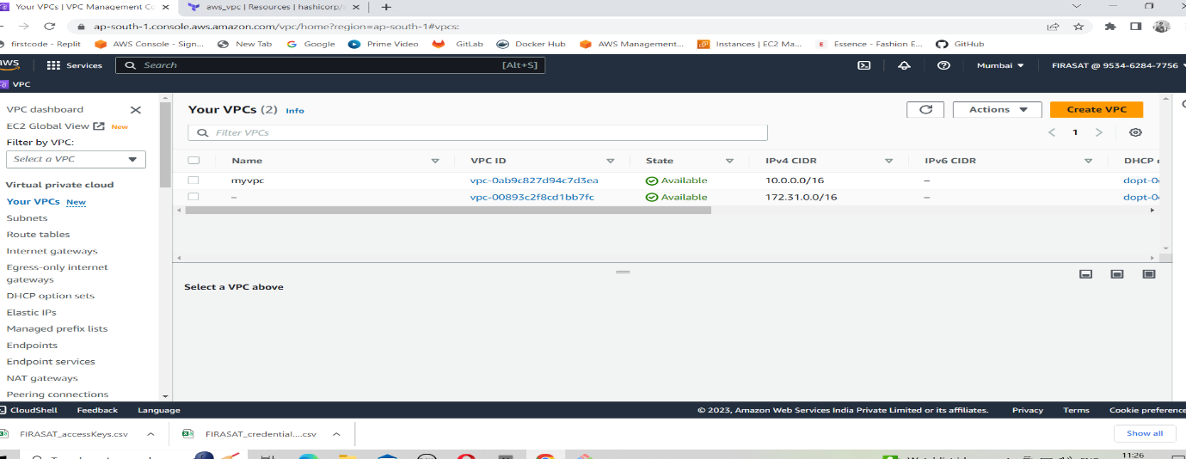

**Step-3**:create a file for the subnet

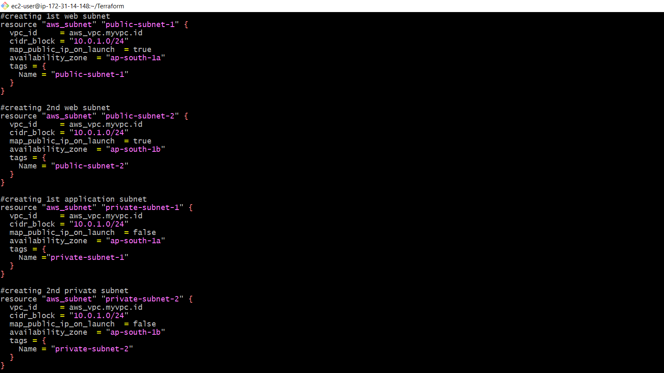

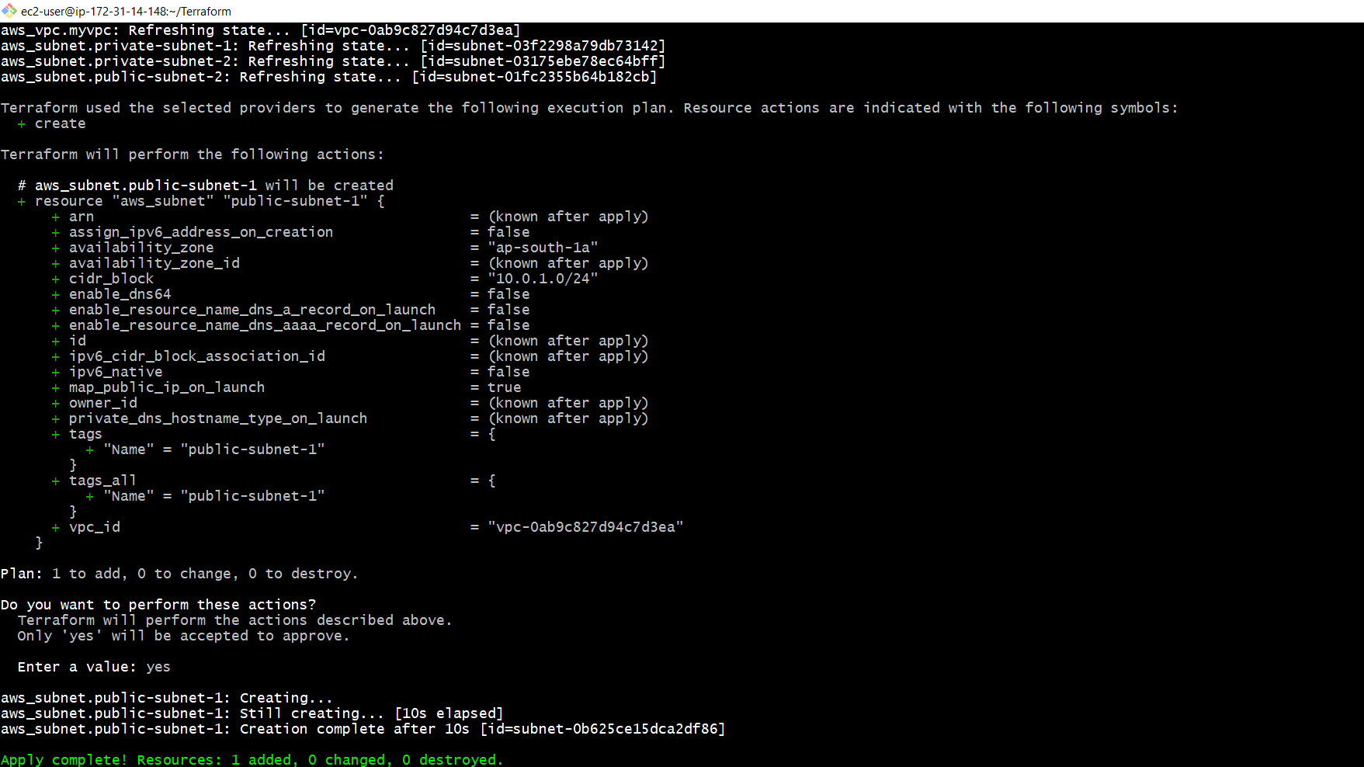

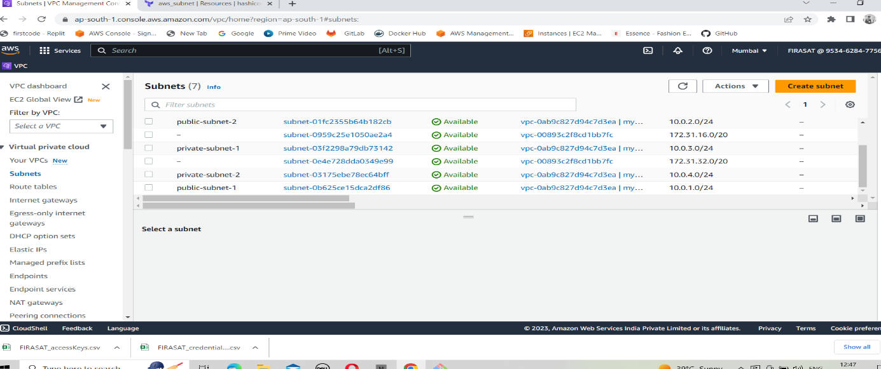

**Step-4**:create a file for the Internet gateway

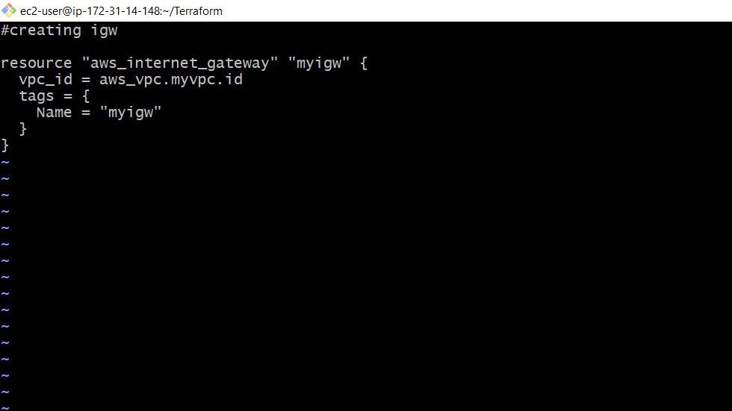

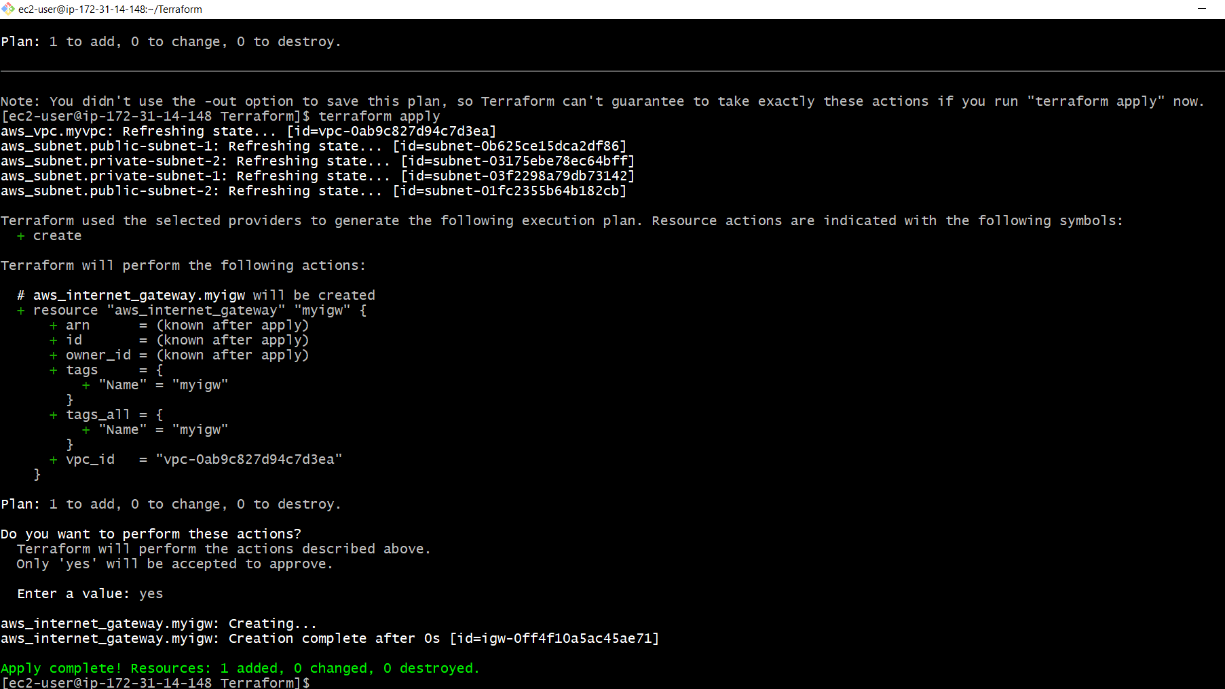

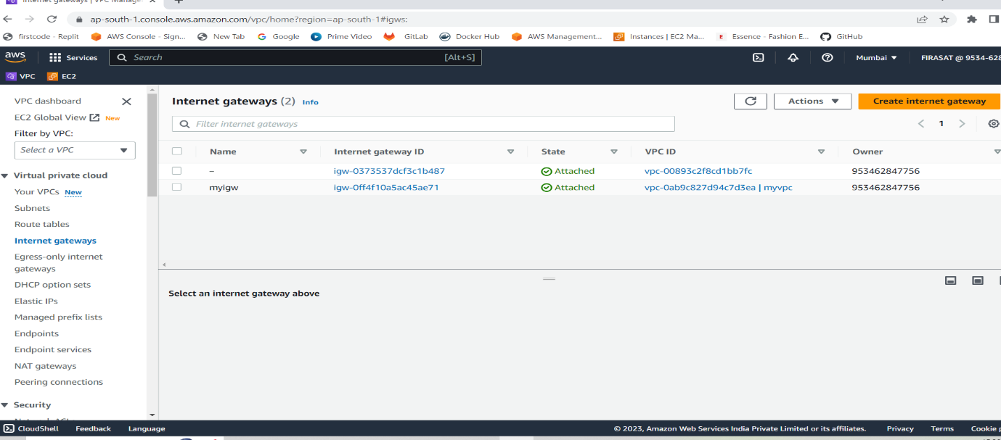

**Step-5**:create a file for route tables

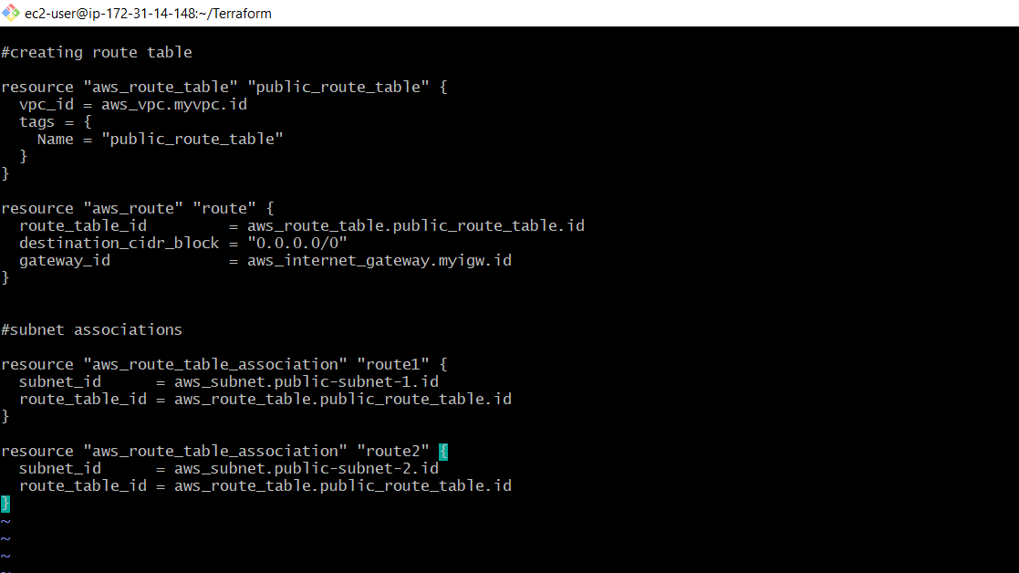

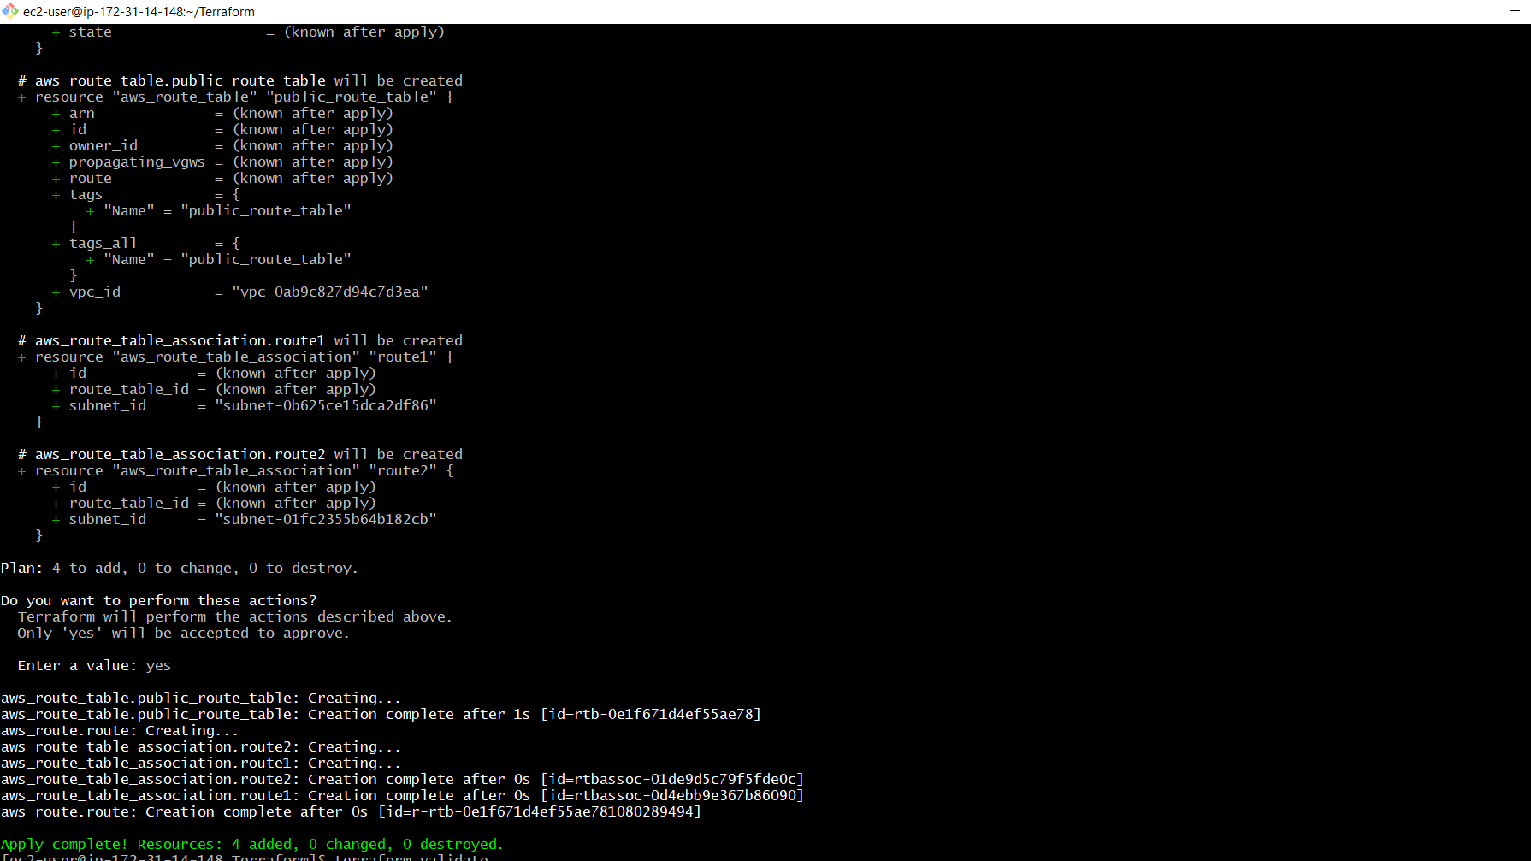

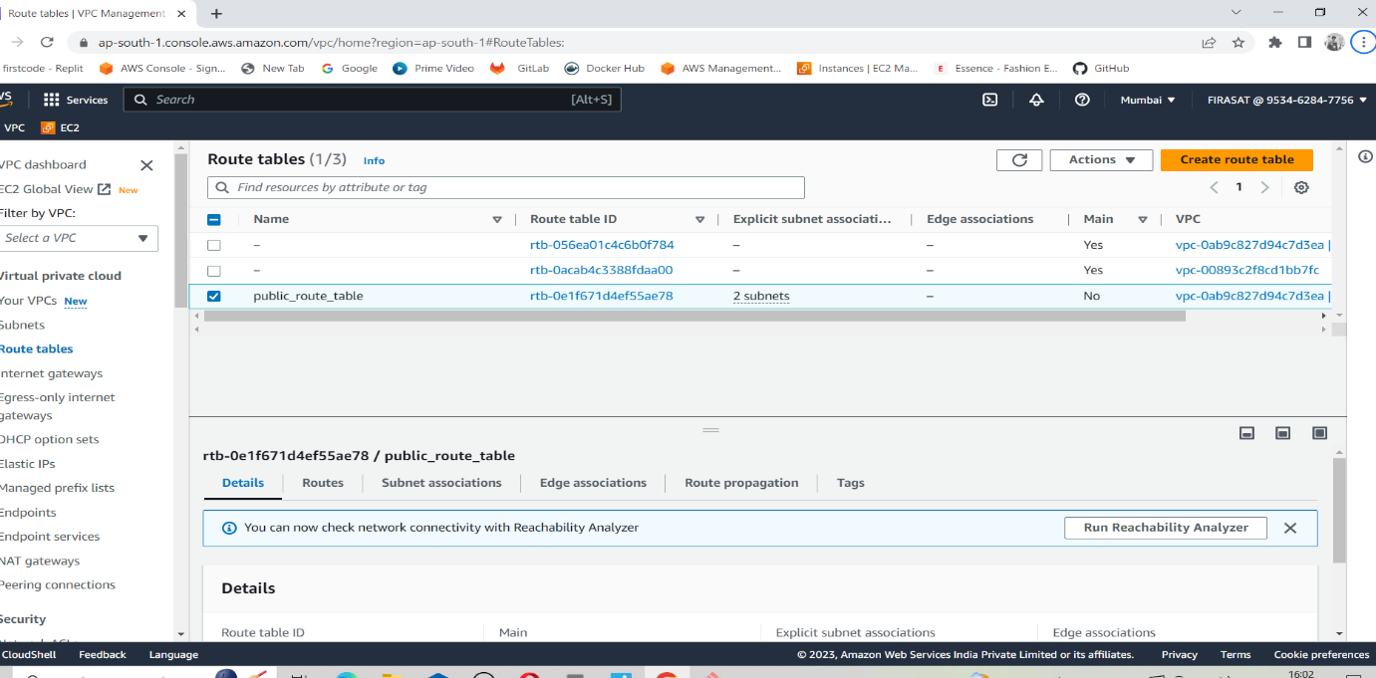

**Step-6**: create a file for security groups

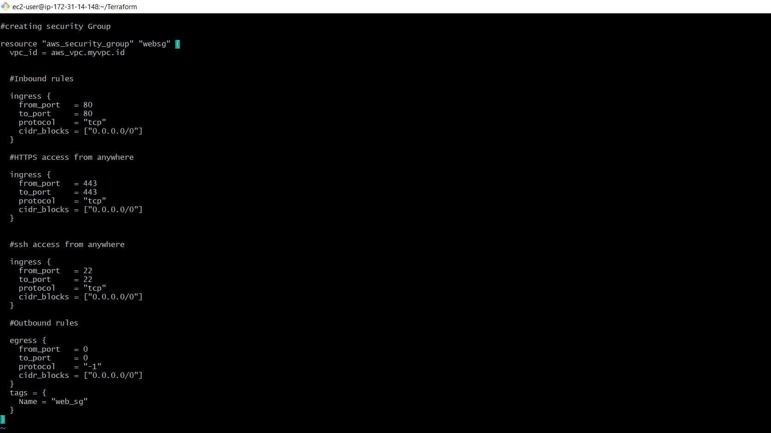

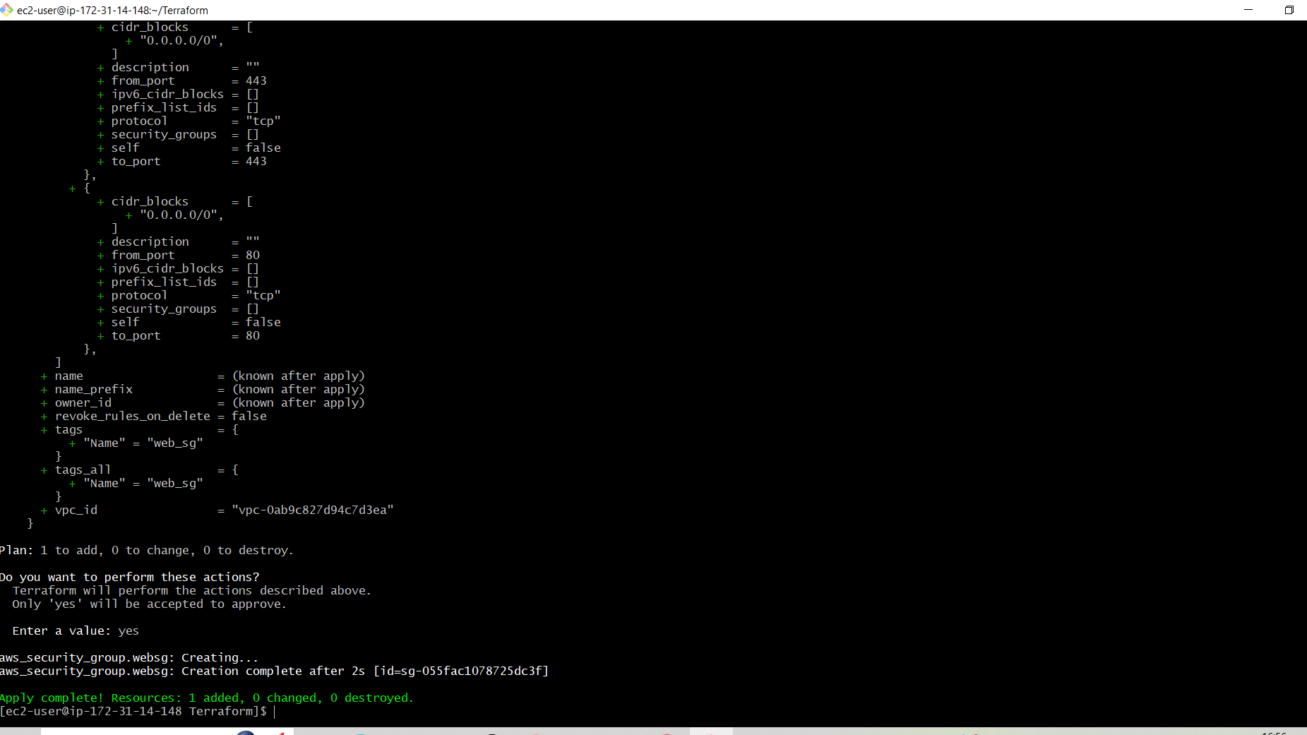

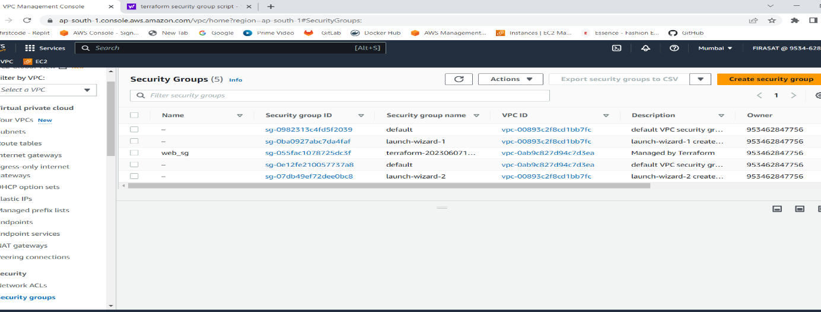

**Step-7**:create a file for ec2

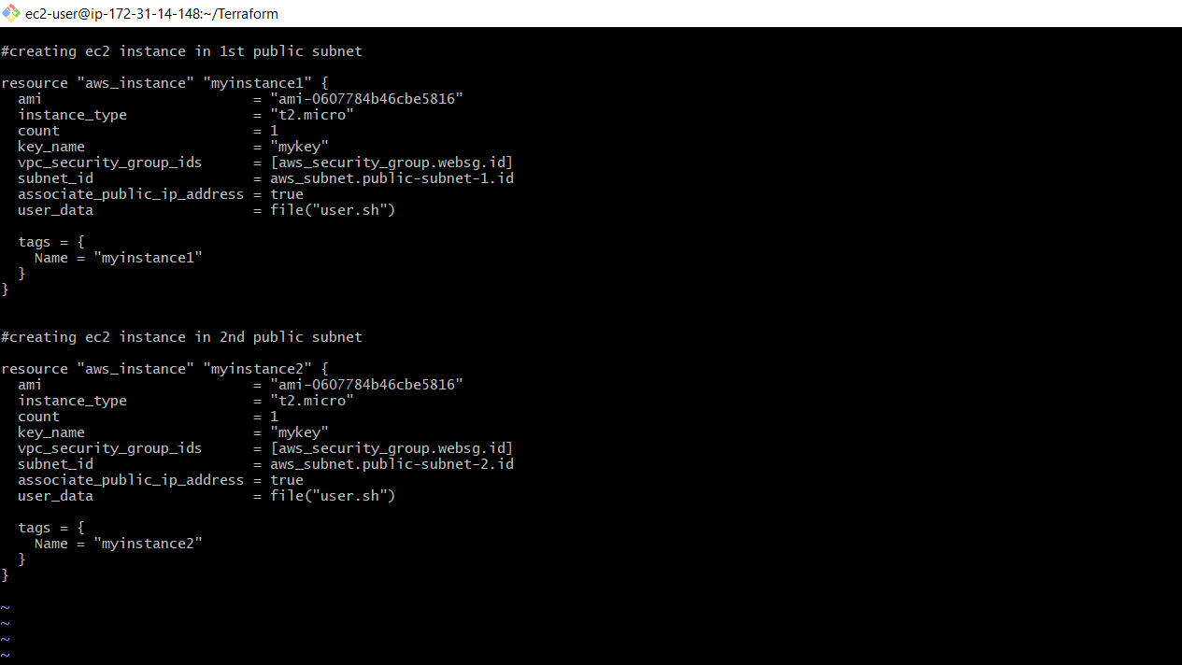

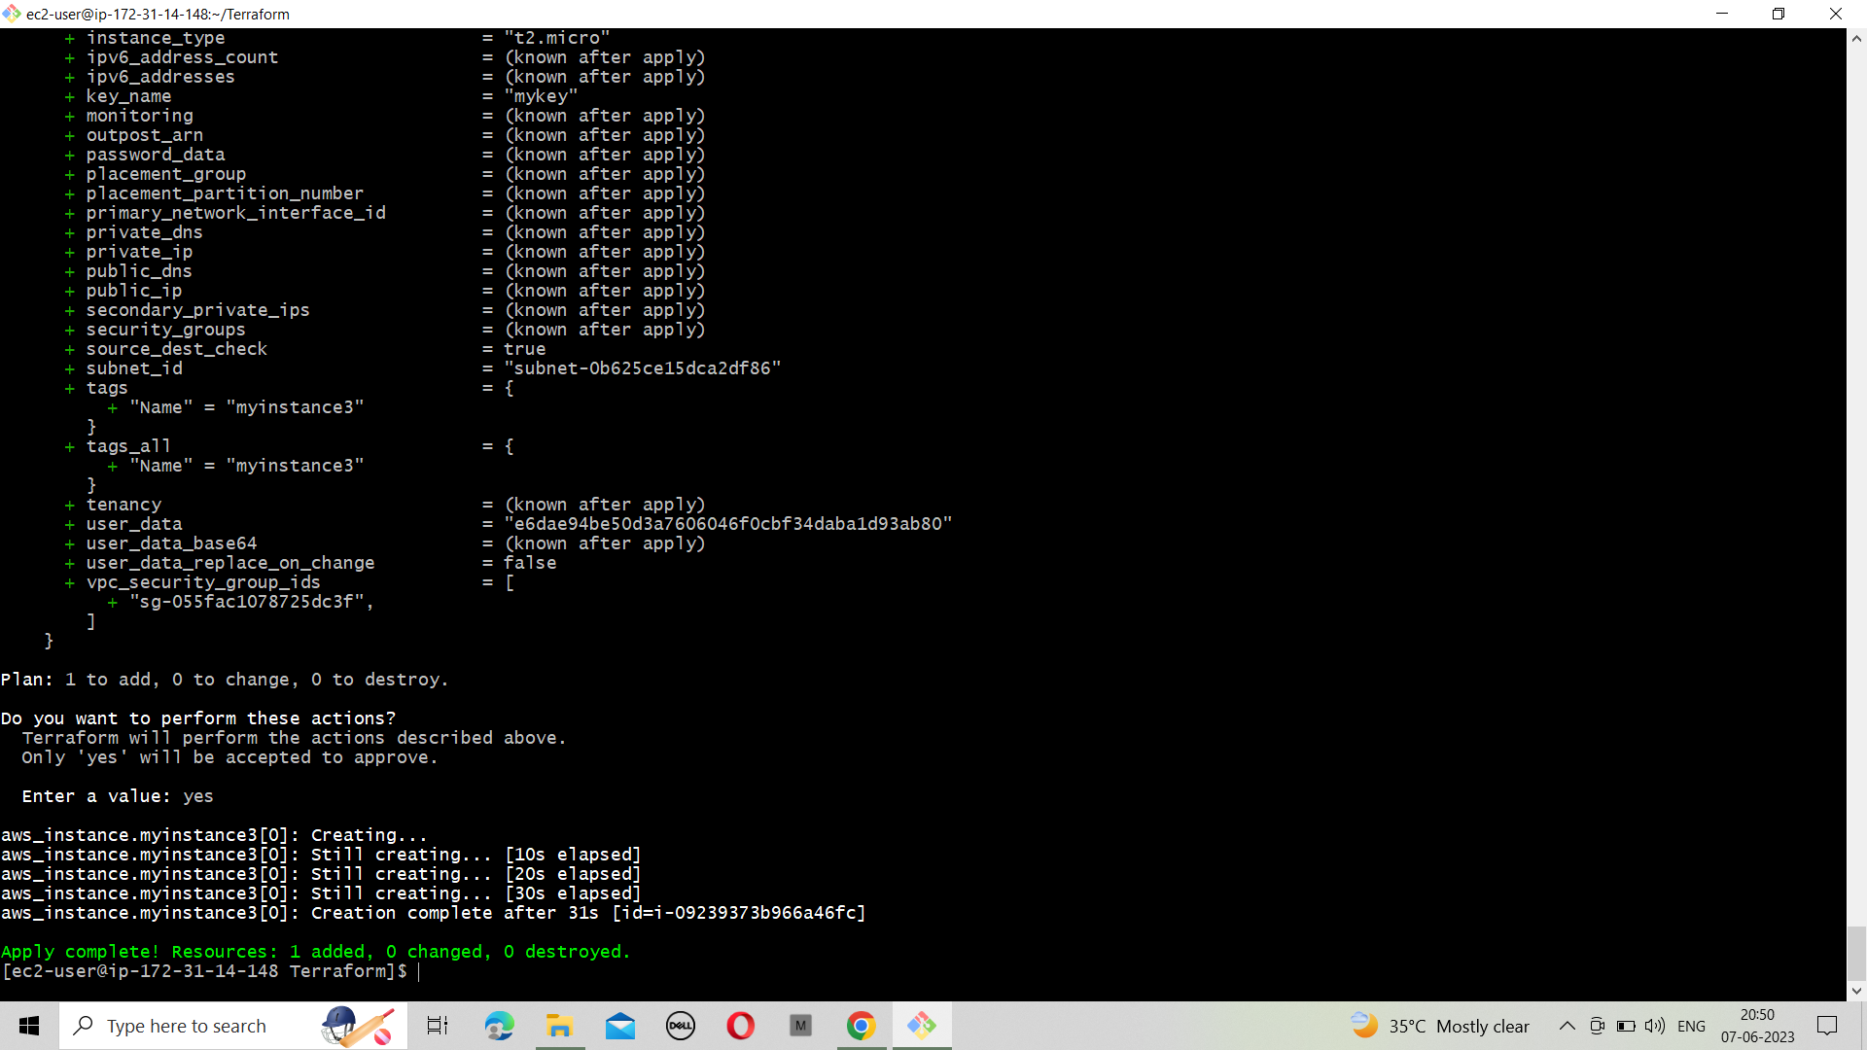

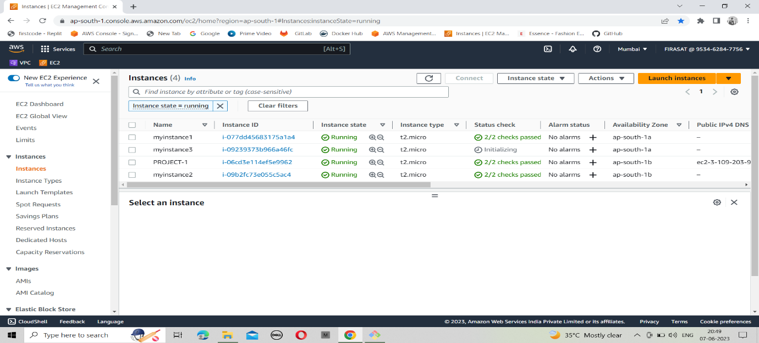

**Step-8**:create a file for the security group for the database tier

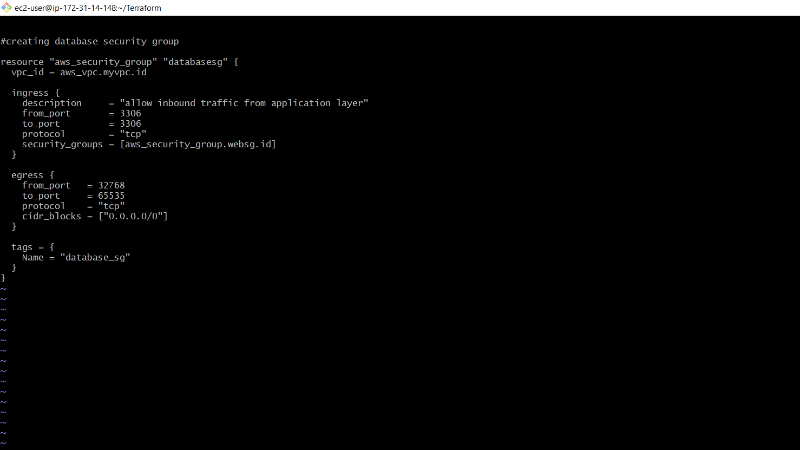

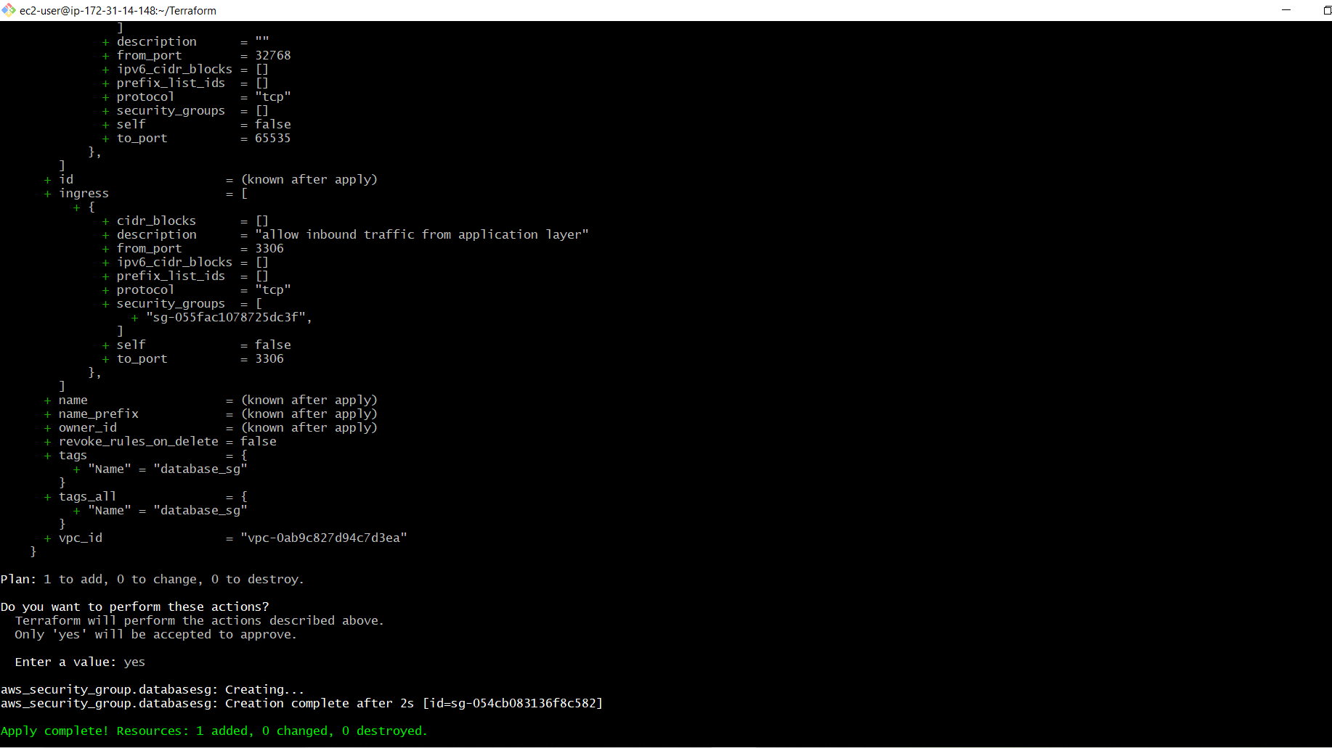

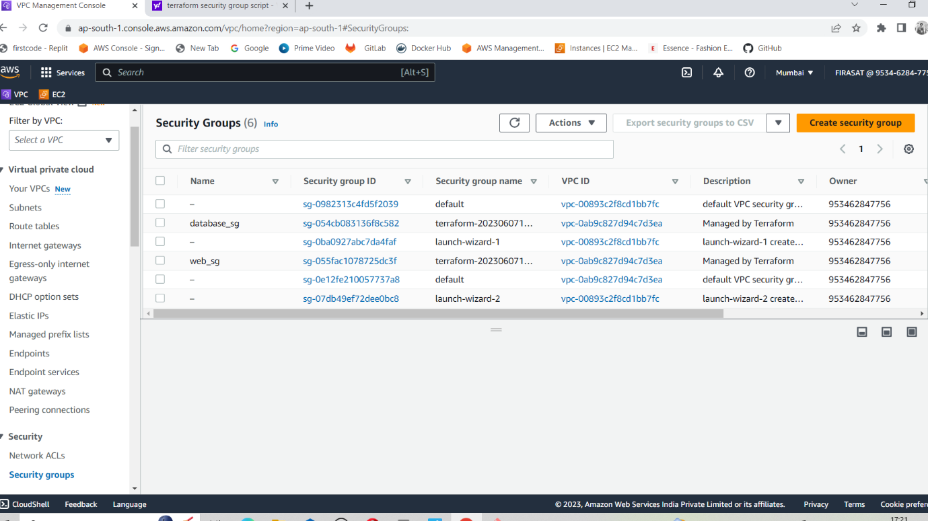

**Step-9**:create a file for the load balancer

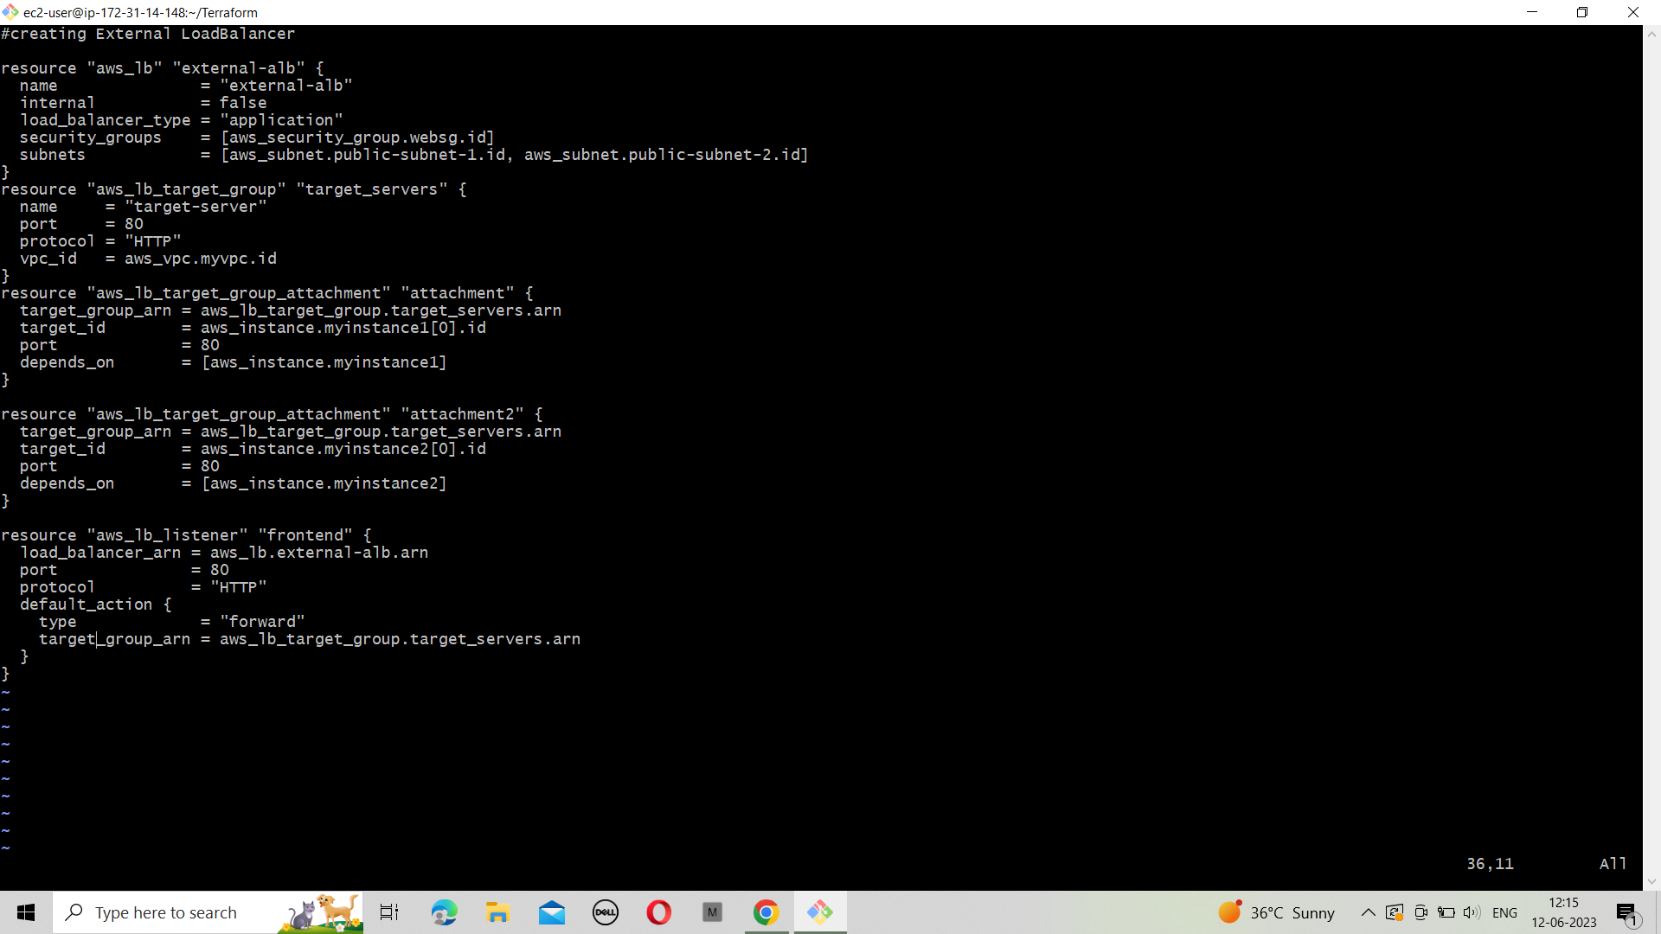

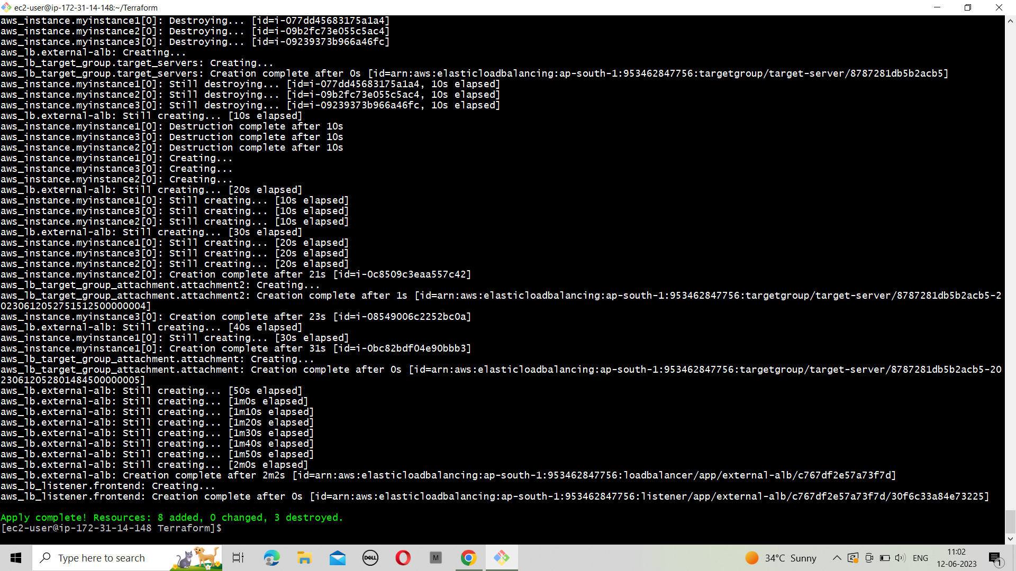

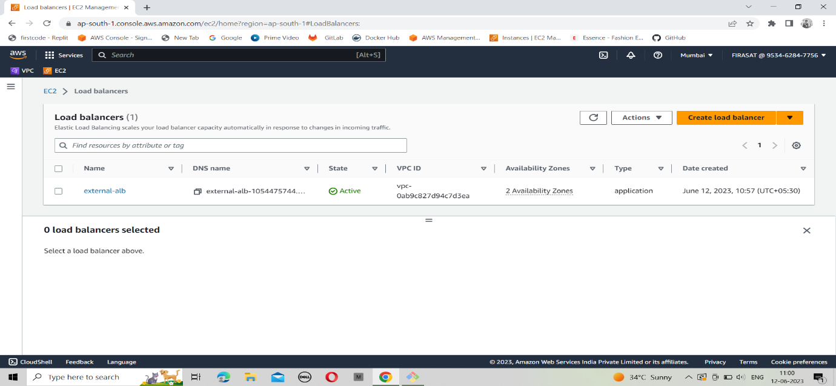

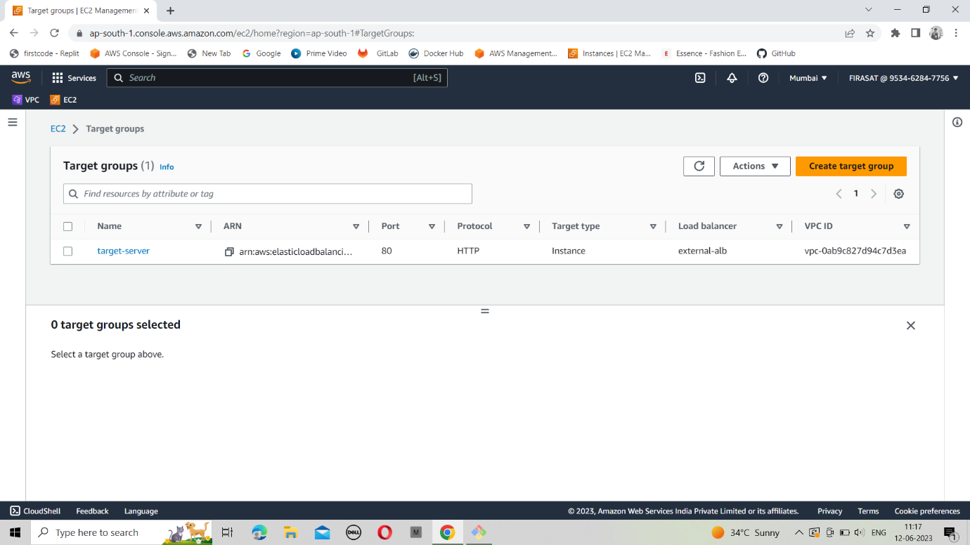

**Step-10**:create a file for RDS instance

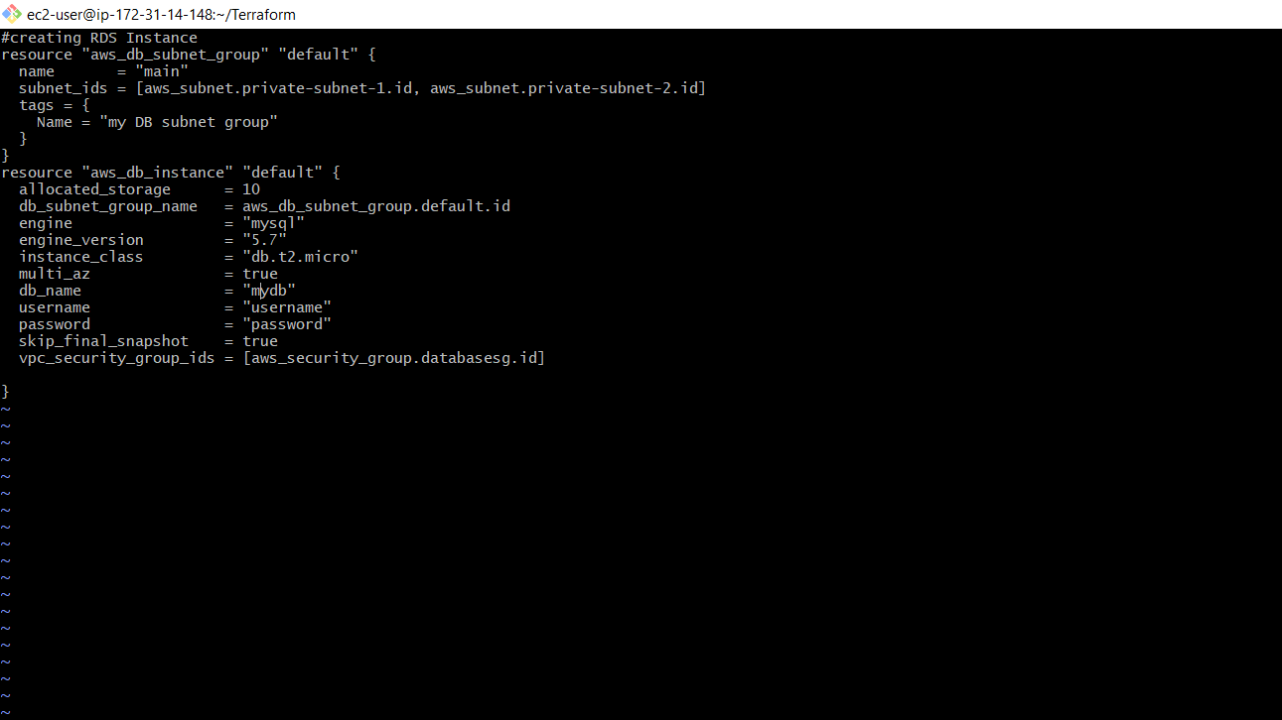

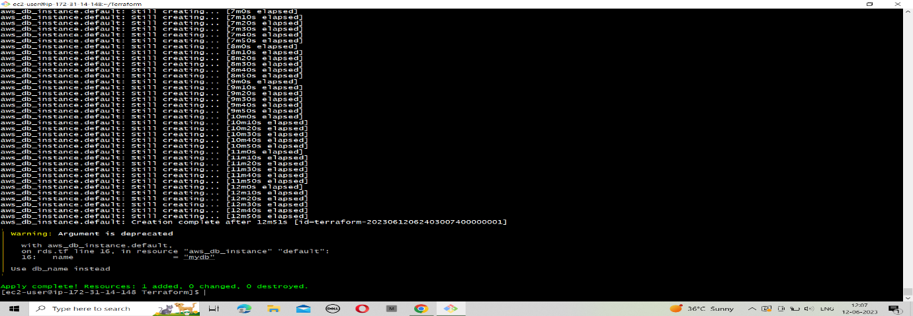

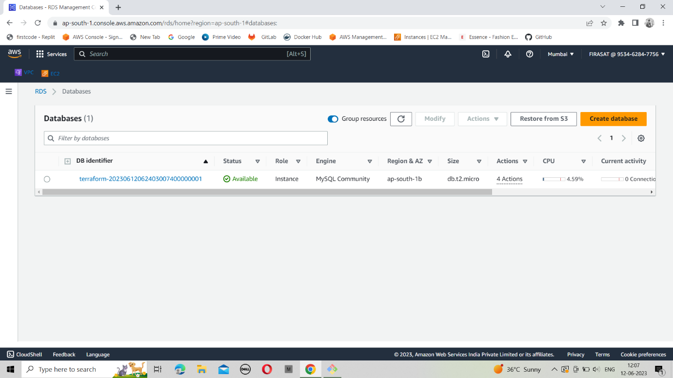

**Step-11**:create a file for outputs

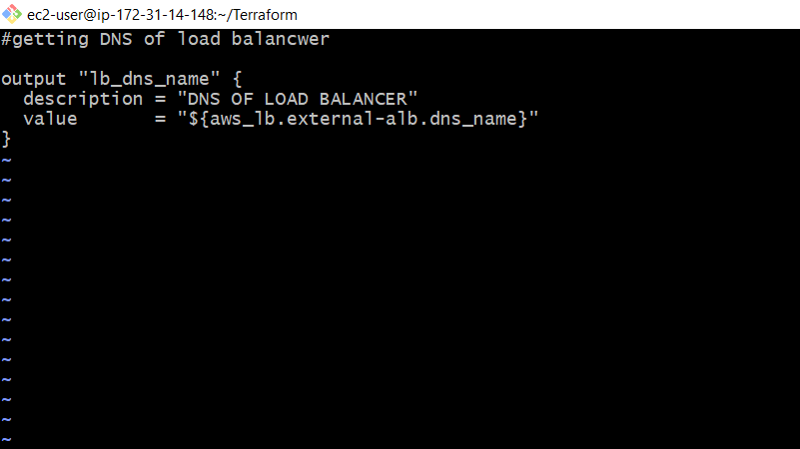

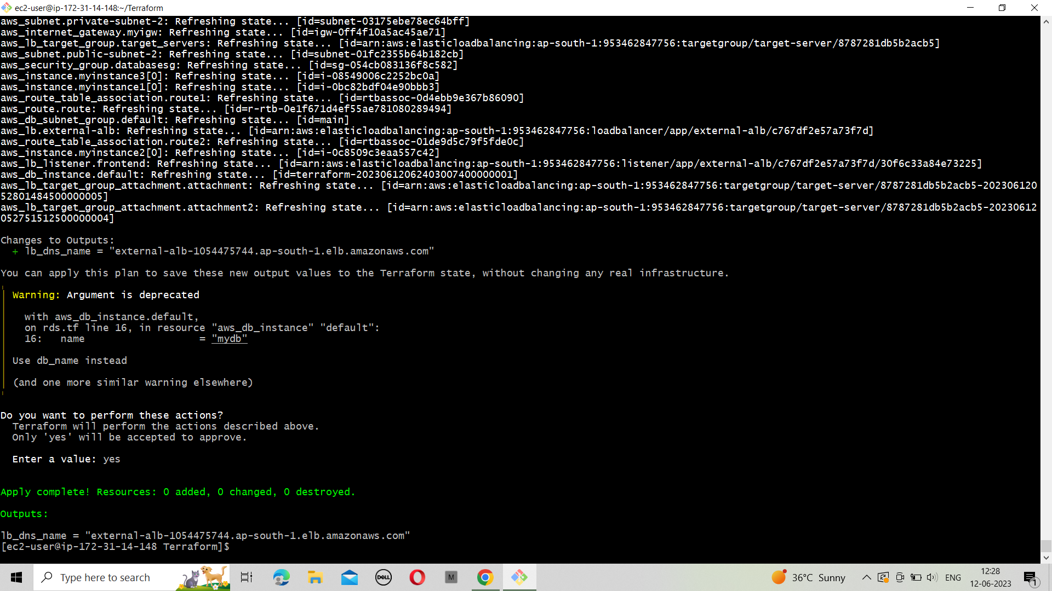

**Step-12**: create a file for user data

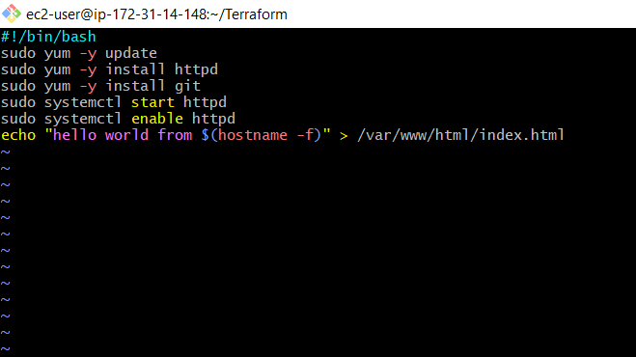

Step-13: Verify the Resources

1. VPC
2. Public & private subnets
3. Route tables
4. Internet gateway
5. EC2 instance
6. RDS instance
7. Application load balancer
8. Security group for web & RDS instance

TERRAFORM SCRIPT AUTOMATION WITH JENKINS

**step-1**: launch an EC2 instance by giving Jenkins port number 8080 in a security group.

**Step-2**: connect the EC2 instance.

Install Jenkins in the EC2 instance by executing the following commands.

* sudo yum update –y
* sudo wget -O /etc/yum.repos.d/Jenkins.repo \

https://pkg.jenkins.io/redhat-stable/jenkins.repo

* sudo rpm --import <https://pkg.jenkins.io/redhat-stable/jenkins>.

io-2023.key

* sudo yum upgrade
* sudo dnf install java-11-amazon-corretto -y
* sudo yum install Jenkins -y
* sudo systemctl enable Jenkins
* sudo systemctl start Jenkins

**step-3**: Connect to http://<your_server_public_DNS>:8080 from your browser. You will be able to access Jenkins through its management interface:

**step-4**:  enter the password found in  **/var/lib/jenkins/secrets/initialAdminPassword**.

Use the following command to display this password:

$ sudo cat /var/lib/jenkins/secrets/initialAdminPassword

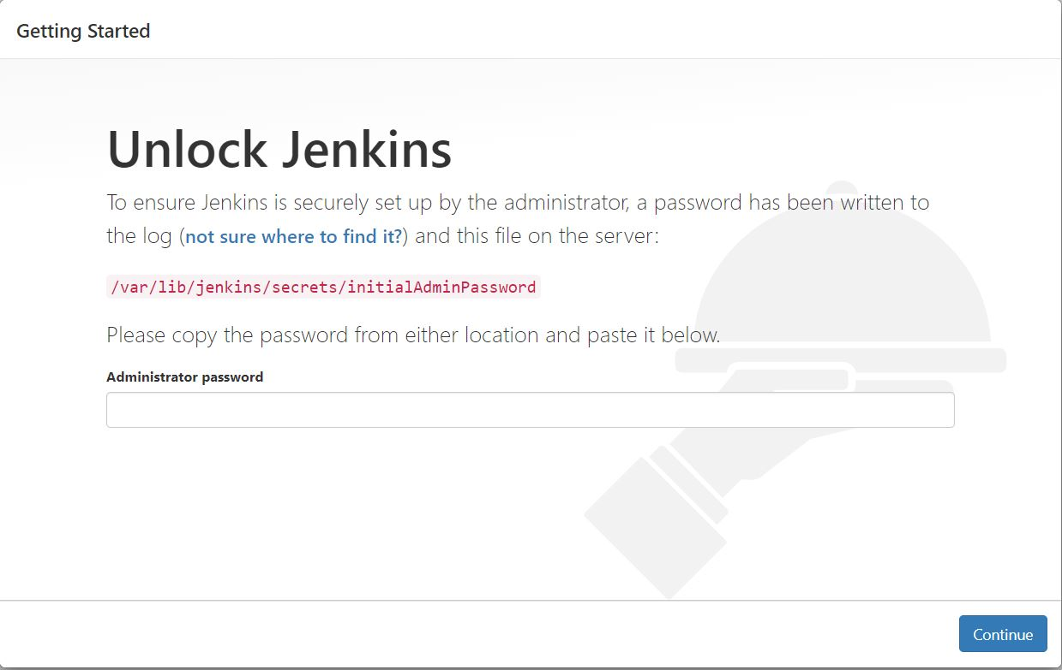

**Step-5**: The Jenkins installation script directs you to the customized Jenkins page.

Click Install suggested plugins.

* Once the installation is complete, the **Create First Admin User** will open. Enter your information, and then select **Save and Continue**.

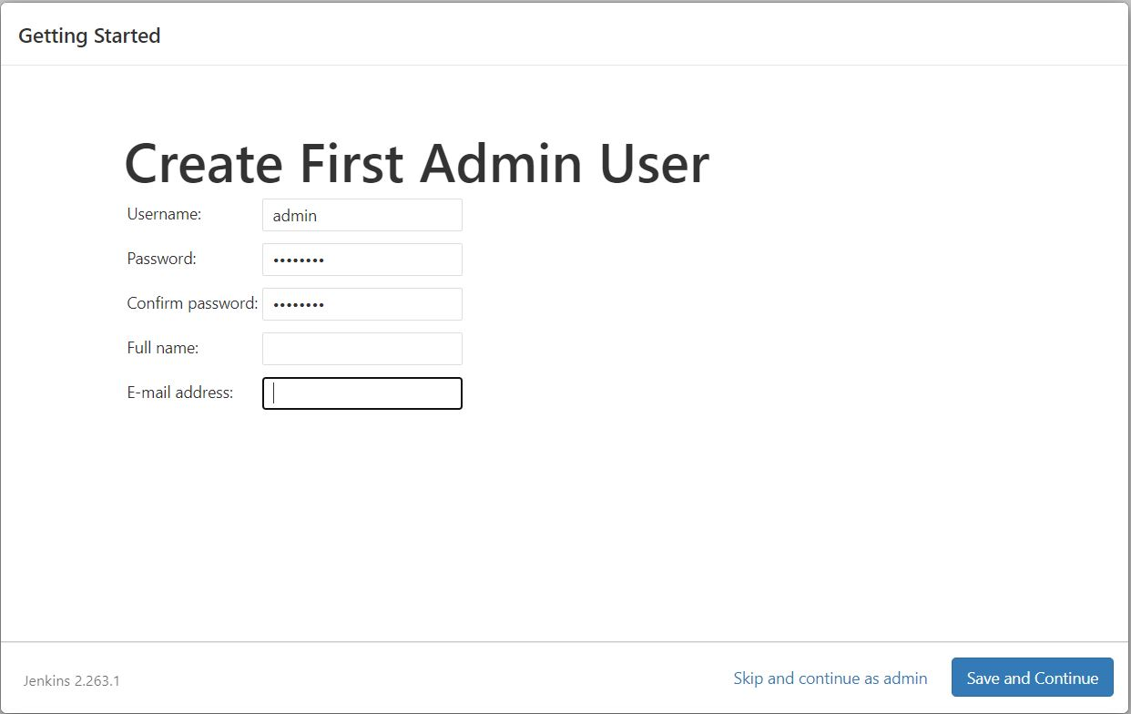

**Step-6**:once the Jenkins profile setup is completed create a new job by clicking on a new item. select freestyle project.

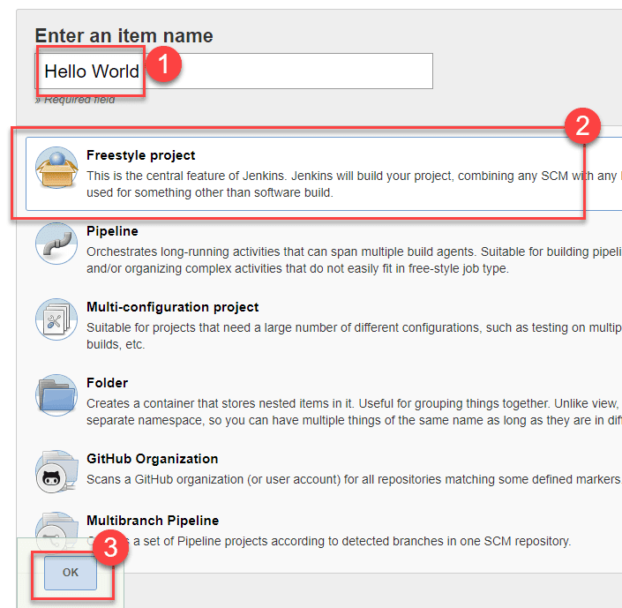

**Step-7**: Enter the details of the project you want to test.

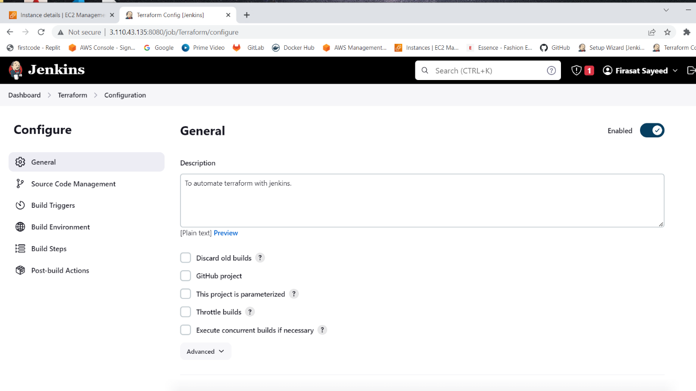

**Step-8**: Under Source Code Management, Enter your repository URL.

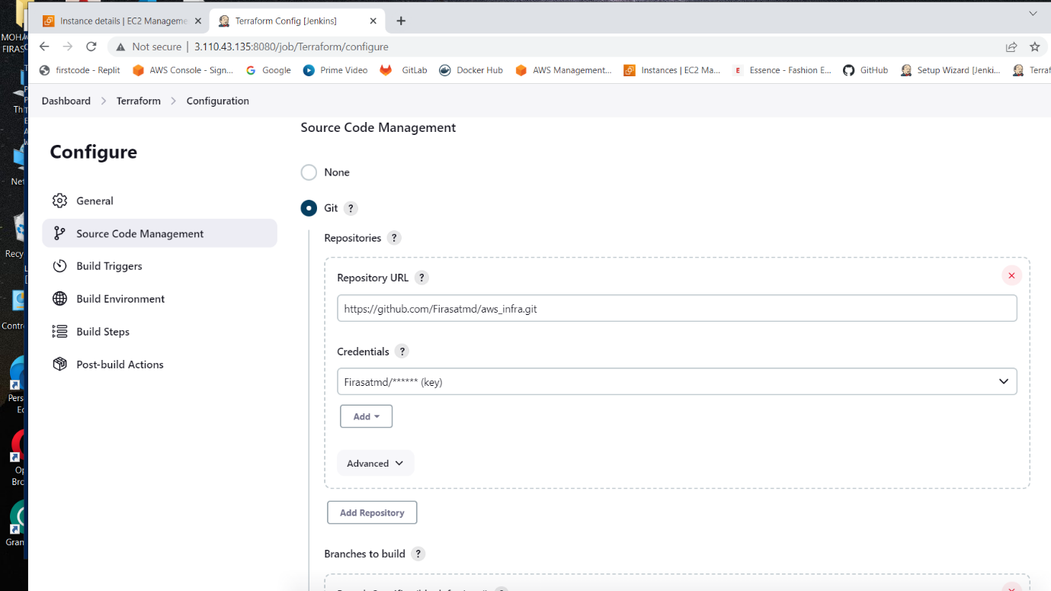

**Step-9**:Under the build section select “add build step” and click on “Execute Shell” and add the commands which you want to execute during the build process

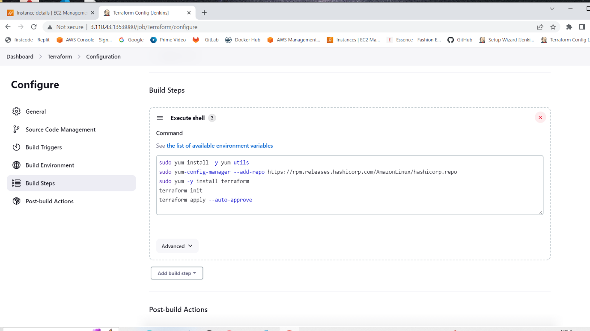

**Step-10**:Click apply and save the project.

**Step-11**:Build source code.

Now, on the main screen, Click the **Build Now** button on the left-hand side to build the source code.

After clicking on Build Now, you can see the status of the build under Build History.

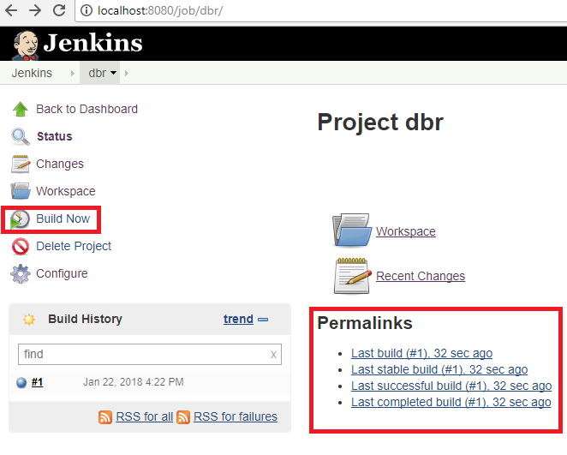

**Step-12**:Click on console output to see the status of the build you run.

